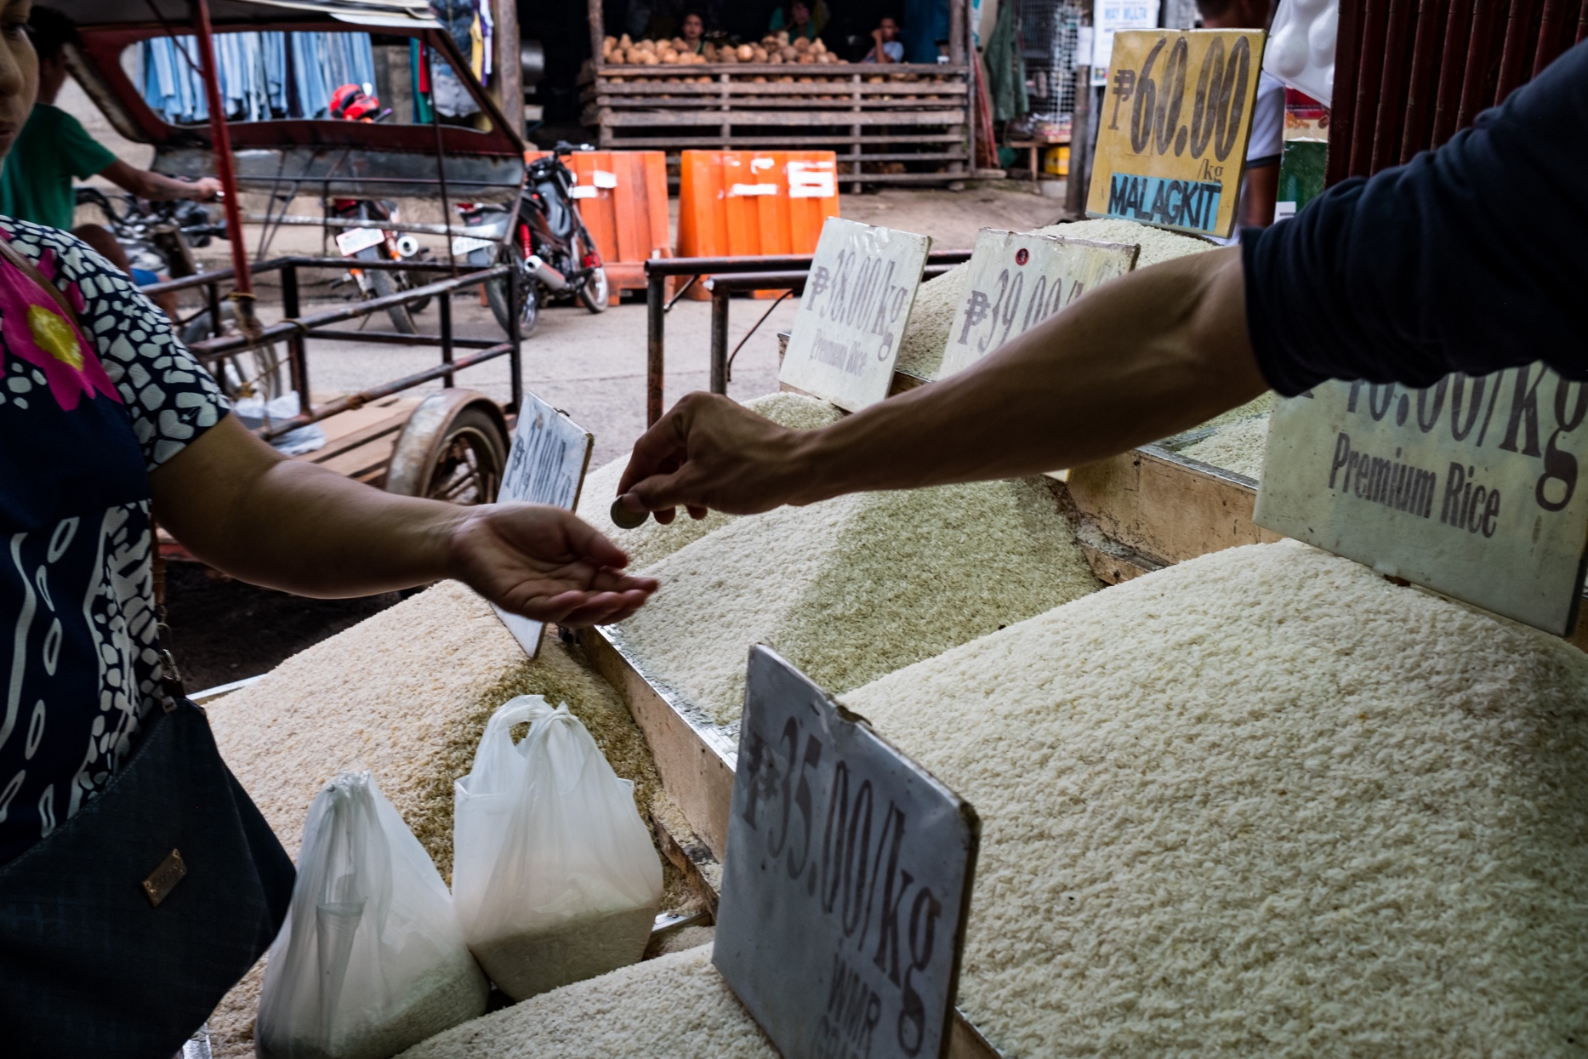

Integrated Natural Resource Management (INRM)

HEARTH Monitoring and Evaluation Toolkit:
Socio-economic Well-being
APRIL 2022

Integrated Natural Resource Management (INRM)
Sound management of natural resources is central to long-term development and resilience. Faced with an urgent need to reduce environmental degradation while improving human well-being, solutions that effectively integrate investments in natural resource management with economic and social development are increasingly urgent. INRM promotes integrated programming across environment and non-environment sectors and across the Program Cycle. INRM supports USAID to amplify program impacts, strengthen gender equality and social inclusion, and identify best practices for integration.
For more information:
https://land-links.org/project/integrated-natural-resource-management-inrm-activity/
Date of Publication: | April 2022
Authors: | Samantha Cheng, Mike Duthie, Daniel Evans, Aaron Ferguson, Andres Gomez, Scott Miller, Christina Seybolt, and Meredith Wiggins
Front Cover photo: | Local markets provide for wants and needs. Being able to purchase rice, fish, and other goods is a primary driver of desire to be involved in conservation enterprise projects. Puerto Princesa, Palawan, Philippines. Photograph by Jason Houston for USAID.

This document was produced for review by the United States Agency for International Development under the Strengthening Tenure and Resource Rights II (STARR II) IDIQ contract number 7200AA20F00010.
The authors’ views expressed in this publication do not necessarily reflect the views of the United States Agency for International Development or the United States Government.
Contents
Acronyms iv
Overview 1
How To Use This Toolkit 1
Indicator Guidance and Core Household Questionnaire 2
Outcomes and Indicators for Socio-economic Well-being 3
Socio-economic Well-being 4
Pathways To Change 4
Recommended Outcomes and Indicators 4
Performance Indicator Reference Sheets 7
Annex 1. Socioeconomic Status 13
Income and Consumption 13
Wealth Indices 13
Poverty Probability Index 14

Acronyms
AWI | Absolute Wealth Index
CWI | Comparative Wealth Index
DHS | Demographic and Health Surveys
FTF | Feed the Future
HEARTH | Health, Ecosystems, and Agriculture for Resilient Thriving Societies
INRM  IP | Integrated Natural Resource Management  Implementing Partner
IWI | International Wealth Index
MERL | Monitoring, Evaluation, Research, and Learning
NGO | Non-Government Organization
PII | Personally Identifiable Information
PPI | Poverty Probability Index
PPP | Purchasing Power Parity
SES | Socioeconomic Status
STARR II | Strengthening Tenure and Resource Rights II
USAID | United States Agency for International Development
USG | United States Government
ZOI | Zone of Influence

Overview
Together, Health, Ecosystems, and Agriculture for Resilient Thriving Societies (HEARTH) and INRM have created the HEARTH Monitoring and Evaluation Toolkit, a suite of indicators and guidance that will help United States Agency for International Development (USAID) Missions and implementing partners (IPs) monitor progress and aggregate common metrics to build the evidence base around the effectiveness of integrated strategic approaches. This document is an individual module from the toolkit, presented separately to facilitate use by individual HEARTH activities. Before using this module, we recommend first accessing the full toolkit and reviewing the list of sectors covered by each module, and determining which are most relevant for your activity:
Access Full Toolkit on Biodiversity Links Here.

How To Use This Toolkit
This toolkit presents a menu of options for outcomes and recommended indicators across the HEARTH activities. Before using this toolkit, activities should have developed a robust theory of change – through first drafting their situation model and results chains during the co-design workshops, many of which have been completed already, and then validating and refining those results chains during start-up workshops.
Based on the activity theory of change, HEARTHs should develop their Activity Monitoring, Evaluation, Research, and Learning (MERL) Plan, which should draw directly from the toolkit. It is not expected that all outcomes or indicators will be relevant for all activities, but that activities should select those in line with their results chains and activity theory of change. Additionally, there might be activity-specific outcomes not included in this toolkit because they were not generally applicable across the HEARTH portfolio, and Missions and IPs should therefore include additional indicators in their MERL plans, as relevant.
When developing activity MERL plans, the indicators in this toolkit are intended to be used both to standardize reporting for monitoring data, as well as a basis for evaluation data collection. While monitoring trends in these indicators over time may be important for some activities, USAID anticipates that Missions and IPs will also identify important questions about the causal impact of their activities during the start-up activities, best answered using evaluation approaches. Which indicators will be part of monitoring systems, and which will be used to answer evaluation questions, will affect how the toolkit is operationalized. In addition, it is expected that MERL plans will likely include qualitative data sources, important to further explaining monitoring and evaluation results and exploring learning questions in more depth, in addition to the quantitative data collected using the approaches from the toolkit.

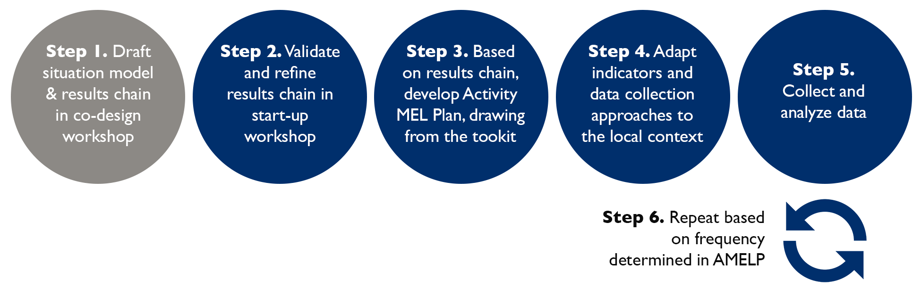

Indicator Guidance and Core Household Questionnaire
This document contains guidance for defining and collecting data for each of the recommended indicators for Missions and IPs, including Performance Indicator Reference Sheets throughout. This guidance draws heavily on established best practices, such as the Demographic and Health Surveys (DHS) and Feed the Future programs. In addition to this guidance, INRM developed a core questionnaire to provide a basis for household surveys to facilitate ease of take-up. It should be emphasized that it is important for Missions and IPs to adapt the questionnaire to their local country context – which might include adding/removing answer choice options, updating question text or translations, etc. Areas where edits for local context are typically required are identified in the tool and following guidance. The full toolkit includes additional guidance on respondent identification and inclusion of household rosters, as well as more in-depth discussions on sampling approaches, data collection administration and frequency, data management, privacy, and ethics, which should be considered.

Outcomes and Indicators for Socio-economic Well-being
Table 1: Overview of Outcomes and Recommended Indicators for the Gender Equity & Social Inclusion Sector.
Outcomes | HEARTH Portfolio Indicators
Increased socio-economic well-being | - Percent of households below the comparative threshold for the poorest quintile of the Asset-Based Comparative Wealth Index (CWI)
Increased financial inclusion | - Percent of households participating in micro-finance, lending programs and/or banking

Socio-economic Well-being

Pathways To Change
HEARTH activities might increase incomes and overall socio-economic well-being due to direct employment or participation in a conservation enterprise, as well as greater agricultural productivity/yields (thus leading to greater agricultural income, or greater consumption of self-produced food allowing household finances to be spent on other purchases). Improved socio-economic well-being should also contribute to greater household resilience to shocks and stressors. Relatedly, some HEARTH activities include approaches directly related to increasing access to credit/finance (e.g., savings groups, microfinance/credit). For others, increases in access to credit/finance might be an indirect outcome due to increased incomes, which might increase demand for such services.

Recommended Outcomes and Indicators
Outcome | Description | Recommended Indicator & Duration
Increased socio-economic well-being | Income and consumption are the foremost measures of socio-economic status, but each has serious limitations to their use. Wealth indices are often used as a proxy for socio-economic status when income or consumption cannot be directly measured accurately/reliably. The Demographic and Health Surveys (DHS) asset-based wealth index is an absolute wealth index (AWI), and includes questions on household members, land/housing, access to finance/banking, water and sanitation, dwelling materials, fuel, livestock, and assets/durable goods, among others. The Comparative Wealth Index (CWI) is then constructed from the AWI to make indices comparable across surveys and time. Methodologies for constructing these indices are well-described and widely accepted in the broader research community, and have been used by both USAID/Bureau for Global Health and USAID/Bureau for Resilience and Food Security. For more in-depth discussion on measuring Socioeconomic Status (SES), please see Annex 1. Socio-economic Status, which includes more details on the limitations and benefits of various approaches outlined here.  In addition to providing a snapshot in time of how wealthy or poor a particular household is relative to a common wealth distribution, the number and type of assets a  household owns is associated with household resilience across national contexts, indicating that asset accumulation can serve as a buffer against shocks (e.g., Jalan and Ravallion 2002, Dercon 2004).  While asset-based indices are cognitively easier for respondents to provide accurate and precise data on, it is still somewhat time consuming to collect all the required data given the breadth of information covered, and so trade-offs with survey implementation costs should be considered. | Indicator: Percent of households below the comparative threshold for the poorest quintile of the Asset-Based CWI  Source: Feed The Future (FTF) Indicator EG-g [Zone of Influence (ZOI)-level] Percent of households below the comparative threshold for the poorest quintile of the Asset-Based Comparative Wealth Index  Duration: 15 minutes
Increased financial inclusion | Access to microfinance, lending programs and/or banking are some pathways to a household's financial inclusion. Access to financial services is important for households to diversify their livelihood strategies, protect well-being outcomes and manage risks, and women’s access to finance and credit can be an important pathway for empowerment.  This indicator will measure financial inclusion by collecting data on (1) those who took out a loan or borrowed cash/in-kind and (2) those with formal banking institution accounts. Additional information is also collected on financial access, for those who have not directly taken a loan or borrowed cash/in-kind, but who would have been able to if they wanted. Questions for (1) are adapted from the A-WEAI module of the FTF core questionnaire, and for (2) from the DHS Household Survey. | Indicator: Percent of households participating in micro-finance, lending programs and/or banking  Source: FTF Indicator EG.4.2-7 [IM-level] Number of individuals participating in United States Government (USG)-assisted group-based savings, micro-finance, or lending programs; EG.4.2-a [ZOI-level] Percent of households participating in group-based savings, micro-finance, or lending programs  Duration: 5-10 minutes

Performance Indicator Reference Sheets
INDICATOR TITLE: Percent of households below the comparative threshold for the poorest quintile of the Asset-Based CWI
DEFINITION:
This indicator reflects the percentage of households whose ownership (or lack thereof) of selected assets places the household below a fixed threshold (with a value of -0.9080) that defines the poorest quintile (bottom 20 percent) in the cross-nationally, cross-temporally comparable asset-based CWI. Data from reference surveys are used to develop the reference values which allows the wealth index to be compared across countries and time.
The CWI is calculated according to the methodology specified in Rutstein and Stavetieg 2014 using the following standard household level asset variables, plus selected additional country-specific asset variables if any are specified: employment of domestic servants; ownership of agricultural land and size of land; number of people per sleeping room; house ownership; water source; toilet facility (type and shared status); floor material; roof material; wall material; cooking fuel; access to electricity; and possession of radio, television, mobile phone, non-mobile telephone, computer, refrigerator, watch, bicycle, motorcycle or scooter, animal-drawn cart, car or truck, boat with a motor, bank account, cows, other cattle, horses, donkeys, mules, goats, sheep, chicken or other poultry, or fish. It should be noted that not all of these items are material assets, but the list also includes some variables (such as land/home ownership, water source and sanitation facilities, etc.) to capture more multidimensional measures of poverty.
Constructing the CWI indicator involves seven key steps: (1) selection of a reference survey to serve as the point for comparison across all HEARTH activity surveys, (2) calculation of the AWI for the selected reference survey, (3) calculation of a set of anchoring points for the reference survey, (4) calculation of the AWI for the HEARTH activity survey being analyzed, (5) calculation of a set of anchoring points for the HEARTH activity survey being analyzed, (6) conversion of the AWI scores for all sampled households in the HEARTH activity survey being analyzed into comparable scores using the anchoring points calculated in Steps 3 and 4, and (7) determination of the percentage of households below the comparative threshold for the poorest quintile of the reference survey.
For further details on constructing the AWI and CWI, please see the Comparative Wealth Index Section of the Guide to Feed the Future Statistics.
ADAPTATION:
In the interest of preserving data quality, it is important to minimize the number of questions in the household survey questionnaire for each HEARTH activity. However, teams may find that there are important country-specific assets that are not reflected in the core HEARTH survey questionnaire. For selecting country-specific assets, teams should consider whether there are assets typical of the country that, were they not included in the wealth index, would produce an inaccurate reflection of wealth ownership in the country. When identifying this small number (2-3) of country-specific assets, it is important to try to ensure that there is a balance in the extent to which those assets represent both urban and rural types of wealth and are accessible to both urban and rural populations (e.g., a watch), and to avoid including assets that are dependent on infrastructure requirements that are already captured in the core assets (like electricity). However, one can also consider achieving balance in asset selection by choosing two important assets that represent distinctly rural (e.g., camel ownership) and urban (e.g., in-home WiFi access) types of wealth.

UNIT:  Percent | DISAGGREGATE BY:  N/A
TYPE:  Outcome | DIRECTION OF CHANGE:  Lower is better
MEASUREMENT NOTES
INTENDED RESPONDENT: | Primary adult decision-maker for the household, who would be most knowledgeable about overall household management.
REPORTING NOTES
In addition to reporting the percent value, the number of participant households of the activity must be reported, to allow a weighted average percent to be calculated across HEARTH activities for reporting. Additionally, activities should report on the total sample size (including any disaggregation for participant households vs. comparison/control households if an evaluation is being conducted).

INDICATOR TITLE: Percent of households participating in micro-finance, lending programs and/or banking
DEFINITION:
This indicator tracks financial inclusion through individual participation in microfinance, lending programs and/or banking. The benefits of financial inclusion include lower transaction costs of day-to-day interactions (e.g., Mobile Money) and access to credit to invest in Micro, Small and Medium enterprises. According to the World Bank, microfinance can be defined as approaches to provide financial services to households and microenterprises that are excluded from traditional commercial banking services. Typically, these are low-income, self-employed, or informally employed individuals, with no formalized ownership titles on their assets and with limited formal identification papers.
It should be noted that the indicator captures the numbers who are participating but does not say anything about the intensity of participation.
A household is participating in micro-finance, lending programs, and/or banking if any member of the household took a loan or borrowed cash or in-kind from, or has an account with, a micro-finance or lending program in the past 12 months.
- The numerator is the sample-weighted number of households that participated in micro-finance, lending programs and/or banking in the previous 12 months
- The denominator is the sample-weighted number of households with micro-finance, lending program and/or banking participation data
This indicator will be disaggregated by product type (credit, including microfinance, or banking) and type of institution (formal or informal). Formal institutions include Non-Government Organization (NGO), formal lender (bank/financial institution), and government lender, and informal institutions include informal lender, group-based microfinance (although this may need to be assessed in each local context), friends or relatives, and informal credit/savings groups.
DATA COLLECTION:
Data on increased financial inclusion is measured by collecting data on (1) those who took out a loan or borrowed cash/in-kind and (2) those with formal banking institution accounts. Additional information is also collected on financial access, for those who have not directly taken a loan or borrowed cash/in-kind but who would have been able to if they wanted.
Participation with credit is measured by asking if anyone in the household has taken any loans or borrowed cash/in-kind from 7 different sources in the past 12 months: NGO, informal lender, formal lender (bank/financial institution), friends or relatives, group-based microfinance or lending, informal credit/savings groups, or government lender. This is followed up by a question regarding whether anyone in your household would be able to take a loan or borrow cash/in-kind if they wanted to.
Finally, access to banking is measured by asking if any member of the household has an account in a bank or other financial institution, and whether any member of the household uses a mobile phone to make financial transactions such as sending or receiving money, paying bills, purchasing goods or services, or receiving wages.
ADAPTATION:
To adapt to the country context, locally relevant examples may be given within lending source categories. Additionally, not all types of lending sources might be available in all areas (e.g., government lenders) and therefore sources should only be included, as relevant.
If of interest or directly relevant for HEARTH activities, teams may include similar questions (not to be aggregated into this indicator) on savings.
UNIT:  Percent | DISAGGREGATE BY:  Sex of Respondent: Female, Male  Product Type: Credit (including microfinance), Banking  Type of Institution: Formal, Informal
TYPE:  Outcome | DIRECTION OF CHANGE:  Higher is better
MEASUREMENT NOTES
INTENDED RESPONDENT: | Ideally, this set of questions should be asked both to the primary adult male and female decision-makers in each household. This is because women’s access to finance and credit is a critical pathway for empowerment (and indeed, A-WEAI questions were designed to be asked to men and women).
REPORTING NOTES
In addition to reporting the percent value, the number of participant households of the activity must be reported, to allow a weighted average percent to be calculated across HEARTH activities for reporting. Additionally, activities should report on the total sample size (including any disaggregation for participant households vs. comparison/control households if an evaluation is being conducted).
If a household participates in credit programs and formal banking, they should be counted for each of the product type disaggregates, but only once for the sex disaggregates and overall financial inclusion.

Annex 1. Socioeconomic Status
The following presents limitations to traditional measures of socioeconomic status (SES) including income, consumption, wealth indices, and poverty predictions.

Income and Consumption
Income and consumption are the foremost measures of SES, but each has serious limitations to their use. As summarized by Poirier et al. (2020), “there are challenges in using income or consumption measures in many LMICs, since income can be highly variable from month to month or difficult to accurately measure. Alternatively, consumption data, such as that measured by the Living Standards and Measurement Studies, can be extremely time consuming and expensive to collect.”
While consumption is considered the “gold standard” to measure SES (and indeed, is used by Feed the Future and other USAID programs), the cost and time to collect detailed consumption data can be prohibitive, with standard approaches taking well over an hour. This alone may make it impractical for HEARTH, but it also raises questions about data accuracy as survey duration increases. While one cost-effective approach is to aggregate items into 10-20 high level categories, these approaches come with a large cost in terms of accuracy, as “efforts to aggregate categories or skip less frequently consumed items are consistently biased to underestimate consumption and therefore overestimate poverty.” Some more innovative approaches, such as the Rapid Consumption Survey which relies on a core module and then each household completing one of several optional modules, still take on average 45-60 minutes.

Wealth Indices
Wealth indices are often used as a proxy for SES when income or consumption cannot be measured directly. There are several examples of established wealth indices developed to allow for cross-country comparisons which include the following:
- CWI – Used by Feed the Future and other USAID programs, the CWI calculates wealth indexes that are comparable across surveys and time, and that allow for direct comparison of levels of economic status. Feed the Future survey method guidance for constructing CWI is based on more than 40 questions, covering housing characteristics, asset ownership, and access to basic services, and takes about 5 -10 minutes on average.
- International Wealth Index (IWI) – Similar to CWI but based on a shorter set of questions (7 assets, 3 housing characteristics, and 2 access to basic services questions). There are some drawbacks to this approach, including (1) the loss of information on the full spectrum of assets, and (2) as computations are done at one point in time, there is a risk that the weights in the index will become less meaningful over time.
While wealth indices are more cost-effective to implement than consumption measures, there are concerns about the time scale over which activities would be able to measure change. While impacts to income/consumption could be expected to occur in the short term, the accumulation of assets is likely to occur more slowly, so there is a likelihood that effects on consumption would not necessarily be picked up by changes in wealth indices. Additionally, wealth indices can still be quite lengthy, with some asking questions about more than 40 different assets.

Poverty Probability Index
The Poverty Probability Index (PPI®), managed by Innovations for Poverty Action, is a poverty measurement tool that is statistically-sound, yet simple to use: the answers to 10 questions about a household’s characteristics and asset ownership are scored to compute the likelihood that the household is living below the poverty line.
The PII is an established tool used by nearly 600 organizations around the world, with scorecards currently available for 60 countries. It is accurate - when tested, the difference between scorecard estimates of groups’ poverty rates and the true rates at a point in time for the national poverty line is –1.7 percentage points. Since it is “off-the-shelf”, it would be relatively cost-effective to implement. Using just 10 questions to predict poverty would also significantly reduce data collection costs compared to other approaches and allow more time in the household surveys to measure additional outcome indicators.
However, existing PPIs are limited in that they are not available for all countries in the HEARTH portfolio, namely the Democratic Republic of Congo, Liberia, and Papua New Guinea. Additionally, for some countries, they are based on data that is not the most up-to-date available (e.g., 2010 data for Madagascar). Depending on when the PPIs were constructed, they also use out-of-date poverty lines (e.g., 2005 Purchasing Power Parity (PPP) for the international poverty lines, instead of 2011 PPP). Finally, more up-to-date methods based on machine learning (cross-validation and parameter regularization) have been used to construct the more recent PPI scorecards, but most use an outdated methodology that is less-able to account for sub-national variation.

The Demographic and Health Surveys Program. Wealth index: “The DHS Wealth Index.” The DHS Program - Research Topics. The Demographic and Health Surveys Program, 2016. https://dhsprogram.com/topics/wealth-index/Index.cfm.
Rutstein, Shea O. “Steps to Constructing the New DHS Wealth Index.” Programming Wealth Index. The Demographic and Health Surveys Program, 2014. https://dhsprogram.com/programming/wealth%20index/DHS_Wealth_Index_Files.pdf.
Rutstein, Shea O., and Sarah Staveteig. “Making the Demographic and Health Surveys Wealth Index Comparable.” Making the Demographic and Health Surveys Wealth Index Comparable (English). The Demographic and Health Surveys Program, February 1, 2014. https://preview.dhsprogram.com/publications/publication-mr9-methodological-reports.cfm.
Jalan, Jyotsna, and Martin Ravallion. “Geographic Poverty Traps? A Micro Model of Consumption Growth in Rural China.” Journal of Applied Econometrics 17, no. 4 (2002): 329–46. https://doi.org/10.1002/jae.645.
Dercon, Stefan. “Growth and Shocks: Evidence from Rural Ethiopia.” Journal of Development Economics 74, no. 2 (2004): 309–29. https://doi.org/10.1016/j.jdeveco.2004.01.001.
Feed the Future. “Feed the Future Indicator Handbook.” US Government's Global Hunger and Food Security Initiative, September 2019. https://fr.fsnnetwork.org/sites/default/files/ftf_agriculture_guide_0.pdf.
The module includes follow-up questions for each source on (1) who made the decision to borrow, and (2) who makes the decision about what to do with the money borrowed. These may be included if additional information is desired on intra-household decision-making dynamics related to access to finance.
Feed the Future. “Feed the Future Indicator Handbook.” US Government's Global Hunger and Food Security Initiative, September 2019. https://fr.fsnnetwork.org/sites/default/files/ftf_agriculture_guide_0.pdf.
Rutstein, Shea O., and Sarah Staveteig. “Making the Demographic and Health Surveys Wealth Index Comparable.” Making the Demographic and Health Surveys Wealth Index Comparable (English). The Demographic and Health Surveys Program, February 1, 2014. https://preview.dhsprogram.com/publications/publication-mr9-methodological-reports.cfm.
Given the overlap between FTF and HEARTH countries, the FTF reference surveys/values for Steps 1 through 3 will be used for HEARTH. For additional details, please see the Feed the Future Survey Implementation Document: Guide to FTF Statistics section on guidelines to construct the CWI indicator.
Last revised October 2020: “Guide to Feed the Future Statistics Zone of Influence Survey.” Feed the Future. United States Agency for International Development, October 2020. https://docs.google.com/document/d/1v1xeQ2z5f7QfiHeubHaeeh9o5JBMmYEi/edit#heading=h.i17xr6.
For more on microfinance please see the World Bank FINDEX: “The Global Findex Database.” World Bank Programs. World Bank, 2017. http://www.worldbank.org/en/programs/globalfindex.
The recommended questions on access to credit come from the Abbreviated Women’s Empowerment in Agriculture Index Questionnaire (Module 6.3b): “Feed the Future Zone of Influence Survey Methods - Questionnaire.” Feed the Future, 2020. https://docs.google.com/spreadsheets/d/18drihQ1qe39L1Qj9qXSA0M3Yf7E4MXrR/edit#gid=1928718979.
The recommended questions on access to banking come from the DHS Household Survey (Questions 134 and 135): “Demographic and Health Survey Module Household Questionnaire.” Demographic and Health Survey. United States Agency for International Development, June 19, 2020.
For more discussion, see: Poirier, M.J.P., Grépin, K.A. & Grignon, M. Approaches and Alternatives to the Wealth Index to Measure Socioeconomic Status Using Survey Data: A Critical Interpretive Synthesis. Soc Indic Res (2020). https://doi.org/10.1007/s11205-019-02187-9.
Beegle, K., De Weerdt, J., Friedman, J., & Gibson, J. Methods of household consumption measurement through surveys: Experimental results from Tanzania. Journal of Development Economics, (2012). https://doi.org/10.1016/j.jdeveco.2011.11.001.
Pape, Utz, and Johan Mistiaen. “Measuring Poverty in 60 Minutes.” World Bank Blogs. Nasikiliza, May 12, 2017. https://blogs.worldbank.org/nasikiliza/measuring-poverty-in-60-minutes.
Pape, Utz, and Johan Mistiaen. “Measuring Household Consumption and Poverty in 60 Minutes: The Mogadishu High Frequency Survey.” Berkeley, January 28, 2015. http://cega.berkeley.edu/assets/miscellaneous_files/82-ABCA_-PapeMistiaen.pdf
Note that there have been other approaches not listed here, such as Chakraborty et al. (2016) which developed simplified asset indices that go down to 6 – 18 questions per country, compared to 25 to 47 in the original DHS wealth index. This is not listed due to the smaller geographic coverage (16 countries) and because it seems to be less widely utilized. Source: Chakraborty, Nirali M, Kenzo Fry, Rasika Behl, and Kim Longfield. “Simplified Asset Indices to Measure Wealth and Equity in Health Programs: A Reliability and Validity Analysis Using Survey Data from 16 Countries.” Global Health: Science and Practice 4, no. 1 (2016): 141–54. https://doi.org/10.9745/ghsp-d-15-00384.
Rutstein, Shea O., and Sarah Staveteig. “Making the Demographic and Health Surveys Wealth Index Comparable.” Making the Demographic and Health Surveys Wealth Index Comparable (English). The Demographic and Health Surveys Program, February 1, 2014. https://www.dhsprogram.com/pubs/pdf/MR9/MR9.pdf.
Source: https://www.ru.nl/publish/pages/516298/nice_12107.pdf.
Rutstein, Shea O., and Sarah Staveteig. “Making the Demographic and Health Surveys Wealth Index Comparable.” Making the Demographic and Health Surveys Wealth Index Comparable (English). The Demographic and Health Surveys Program, February 1, 2014. https://www.dhsprogram.com/pubs/pdf/MR9/MR9.pdf.
“The International Wealth Index (IWI),” n.d. https://www.povertyindex.org/about-ppi
See paper on methods underlying the construction of the PPI and validation here: Kshirsagar, Varun, Jerzy Wieczorek, Sharada Ramanathan, and Rachel Wells. “Household Poverty Classification in Data-Scarce Environments: A Machine Learning Approach.” arXiv.org, November 18, 2017. https://arxiv.org/abs/1711.06813.

